**APPLICANT PART**

**STEP -1 :**

At first login to Service plus web portal**: (**<https://tathyasathi.bangla.gov.in/>) to apply for the **Application for Issuance of Age Certificate - GP**

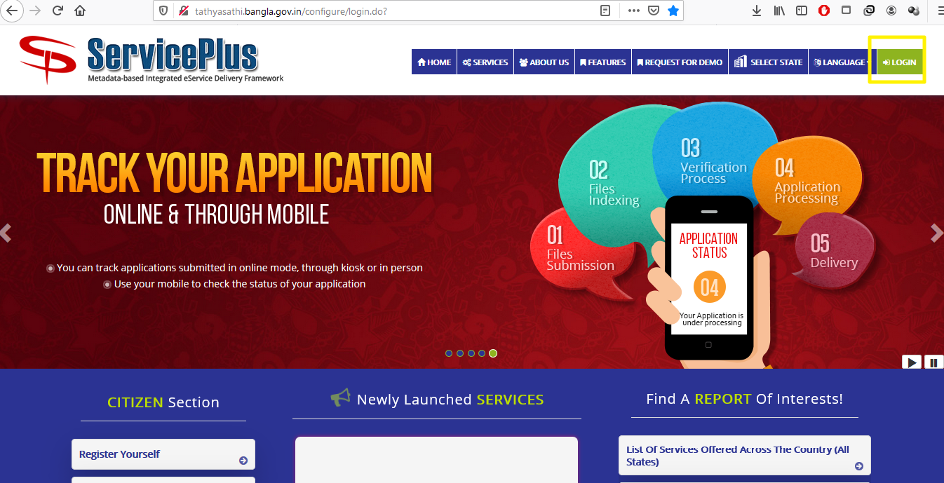

**Step -2:**

Login as Applicant in the Service plus portal.

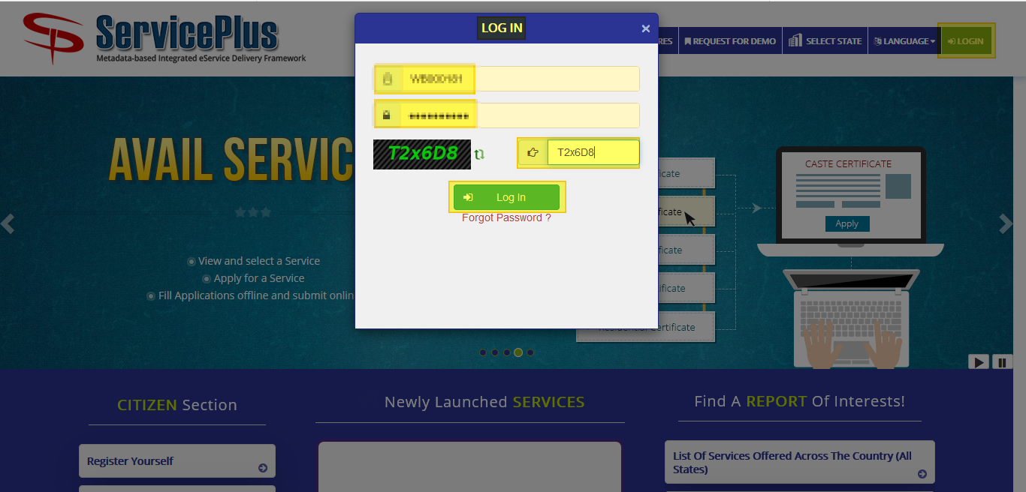

**Step -3:**

Now click “**Apply for services”** and select “**View all available services**”, then Select particular Service and Fill the form:

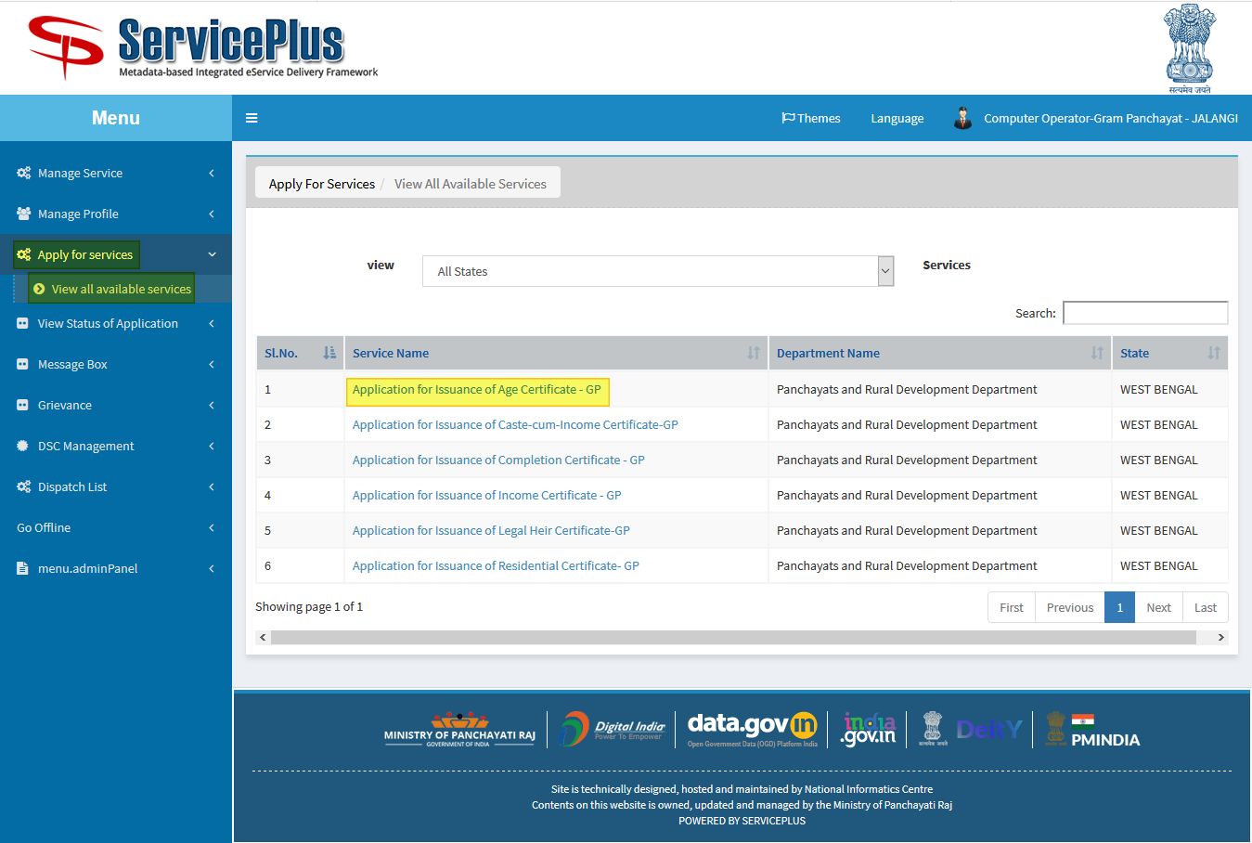

**Step -4:**

Fill the Application Form.

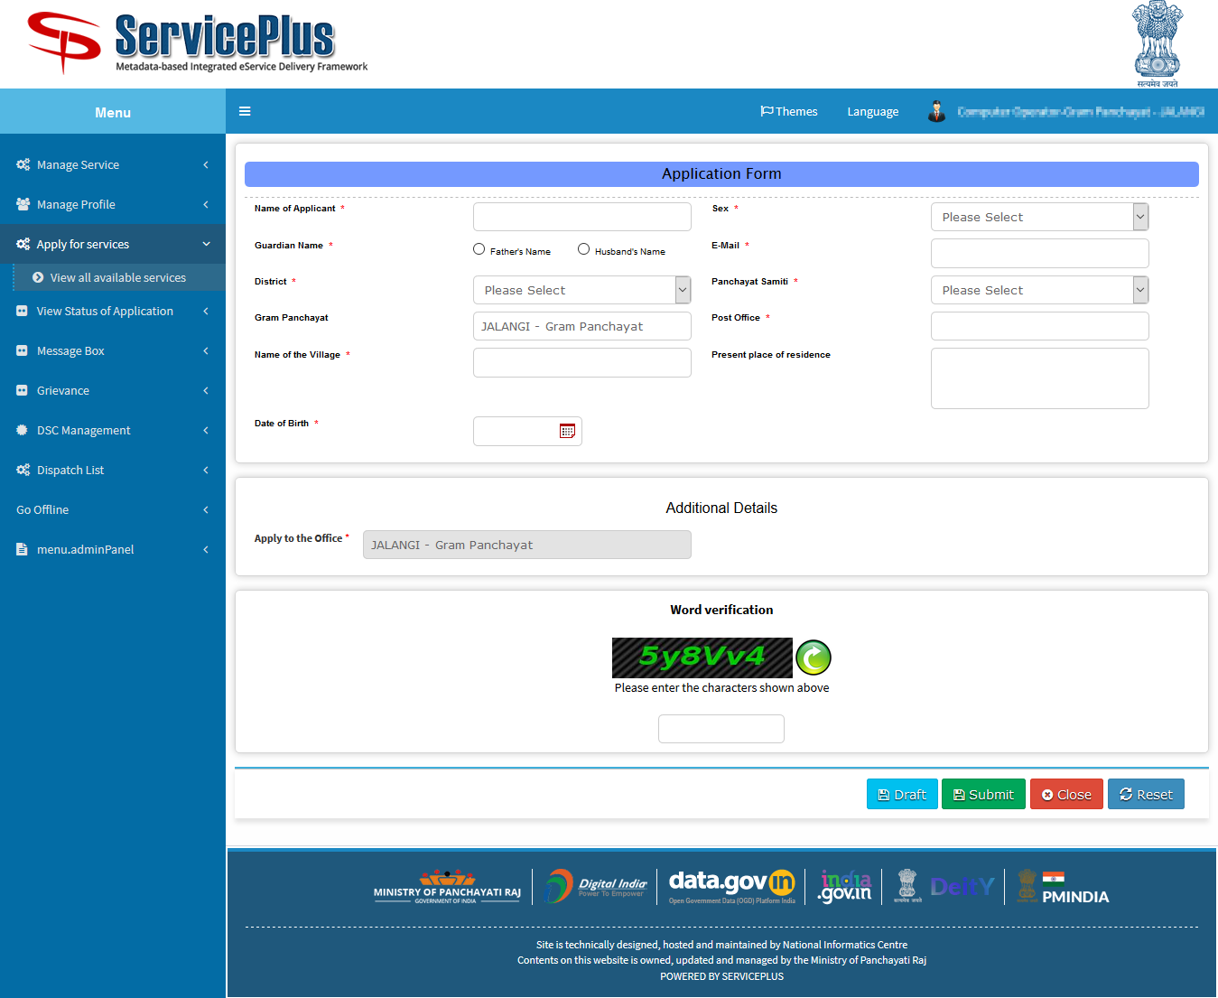

**Step -5:**

Fill the form with the details.

Fill **Date of Birth** to get **Age**.

After that submit by matching the captcha.

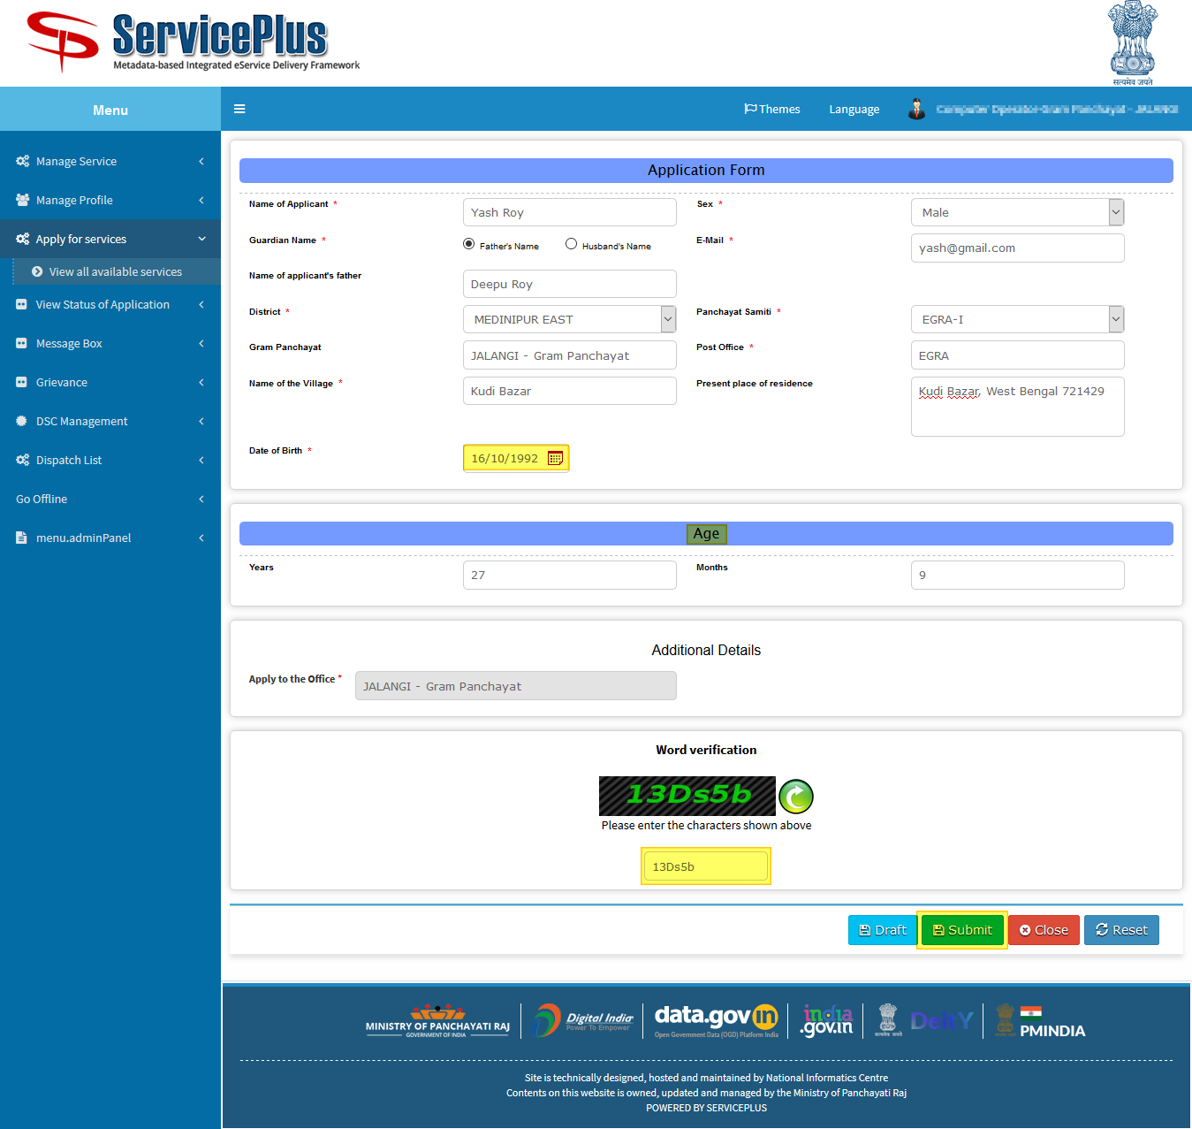

**Step -6:**

Now go through the form and click **submit** for applying.

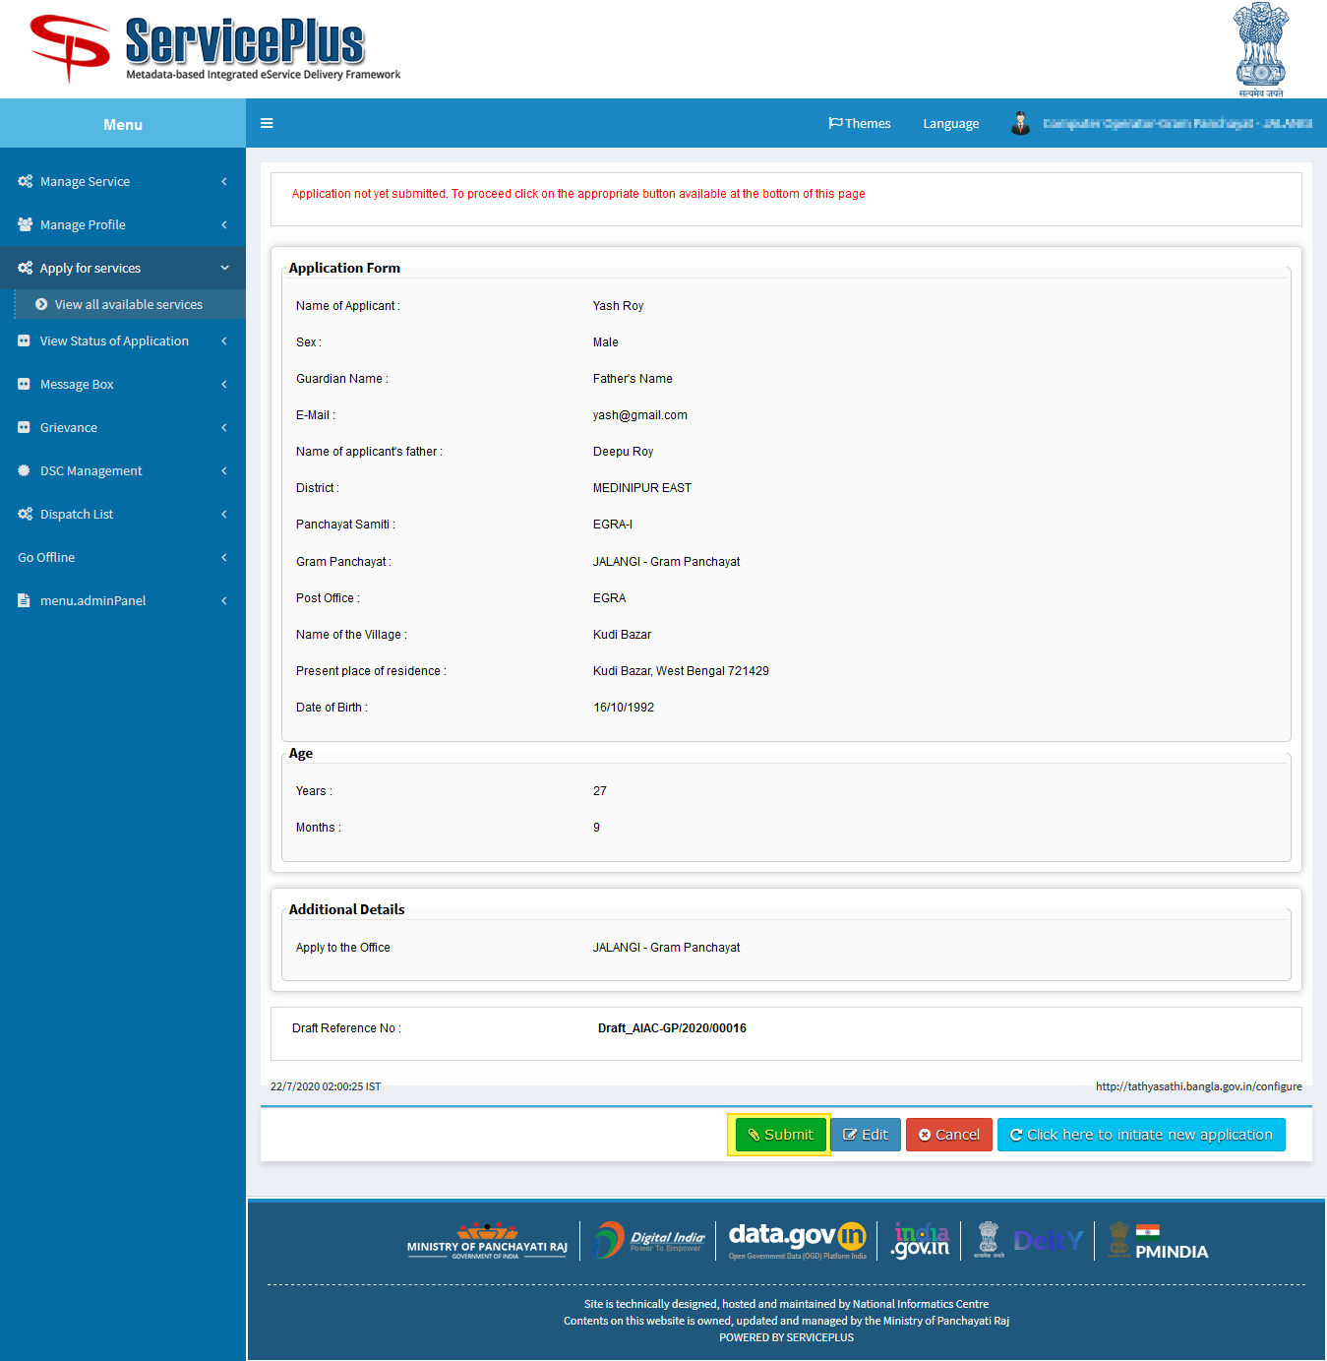

**Step -7:**

After Submission of form an acknowledgement slip is generated with **app reference number.**

Save by selecting “**Export to pdf”** or print it by selecting “**Print”**

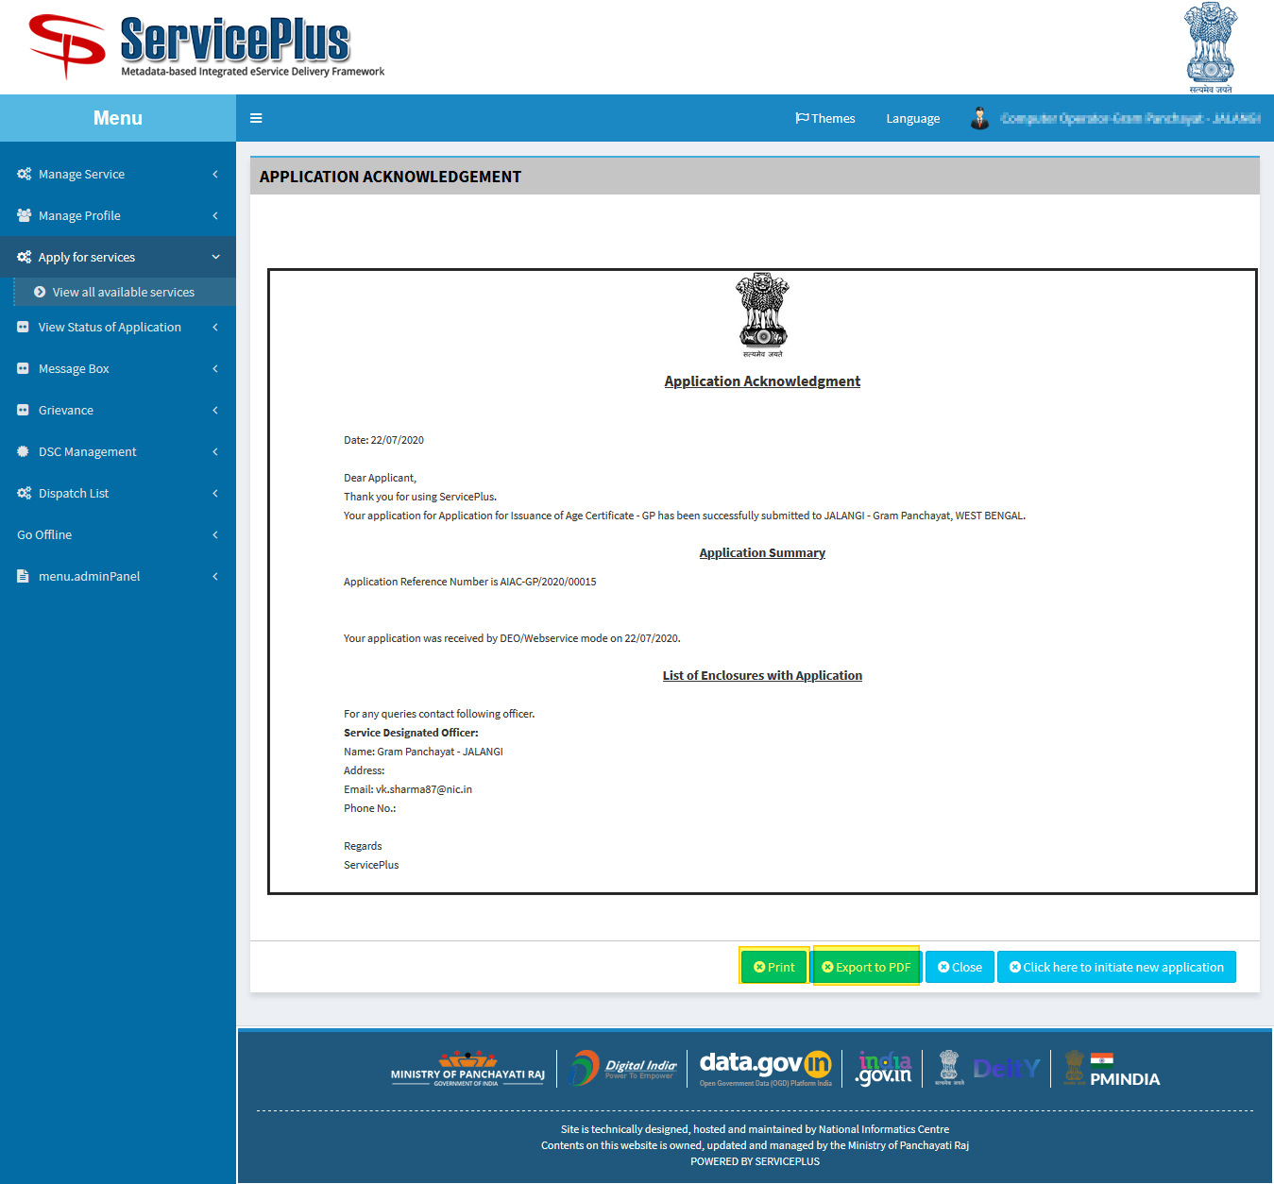

**TRACKING OF APPLICATION**

**Step -1:**

To Track the application we can select “**View Status of Application”** and go to “**Track application status”.**

Here select the appropriate date from to when and it’s optional to give “**app ref no”** to “**get data”.**

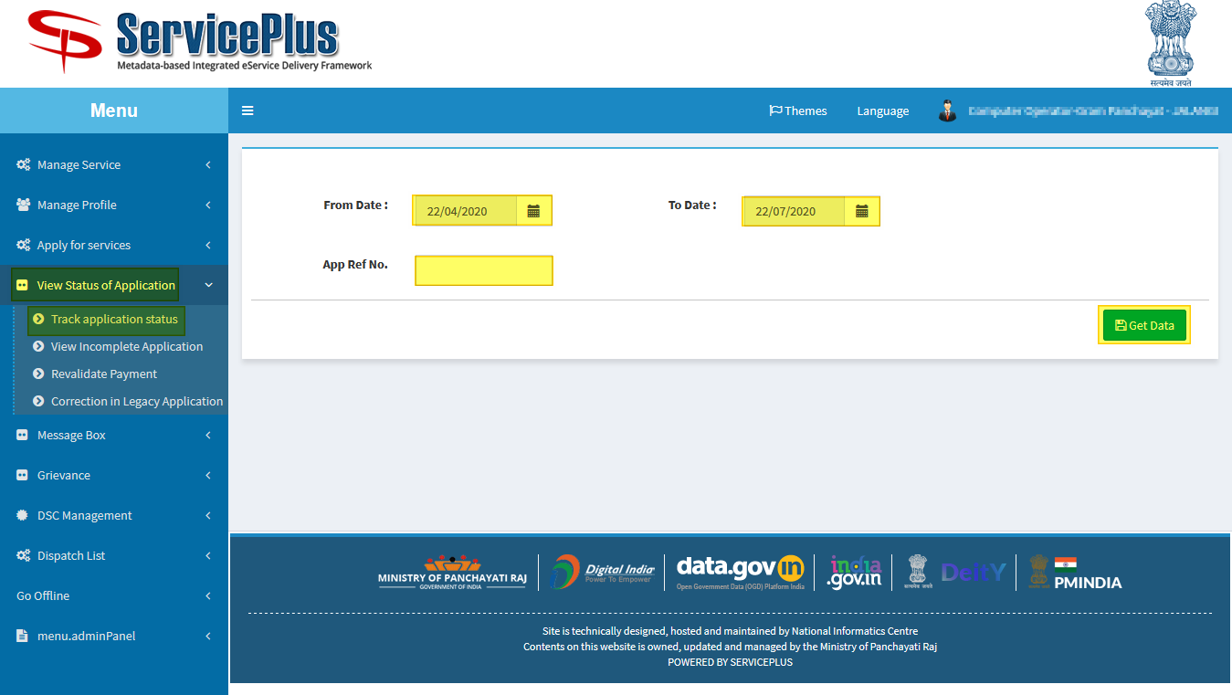

**Step -2:**

Now by getting the application select **“current status”** of the application to keep the track of status of application.

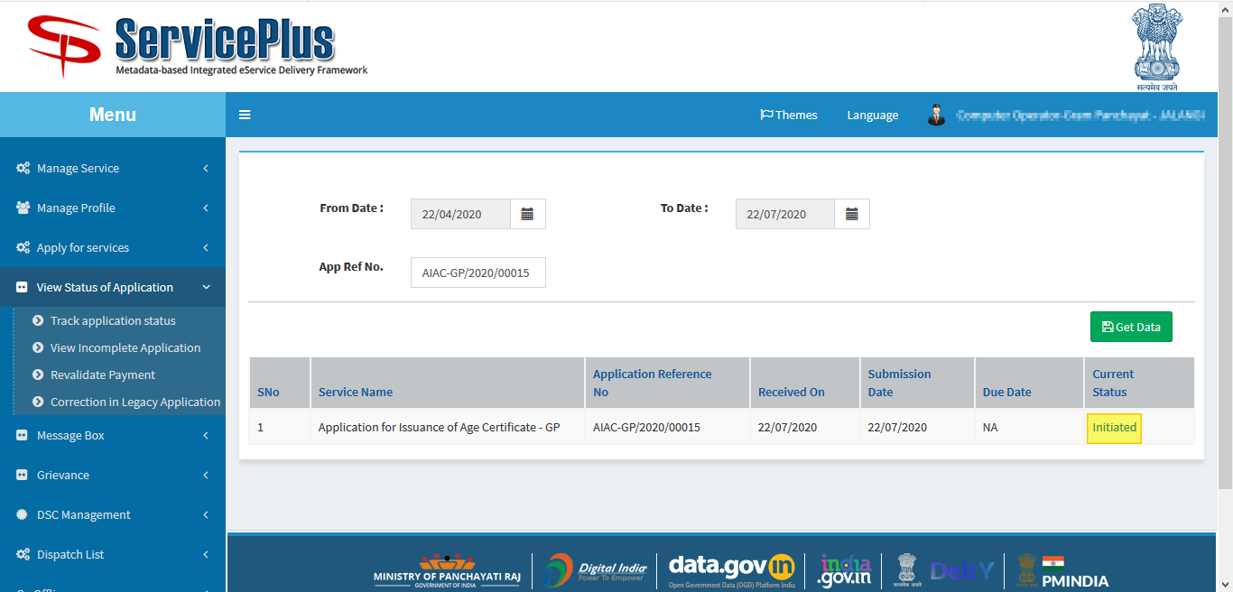

**Step -3:**

Here the application could be viewed and status could be seen of the application.

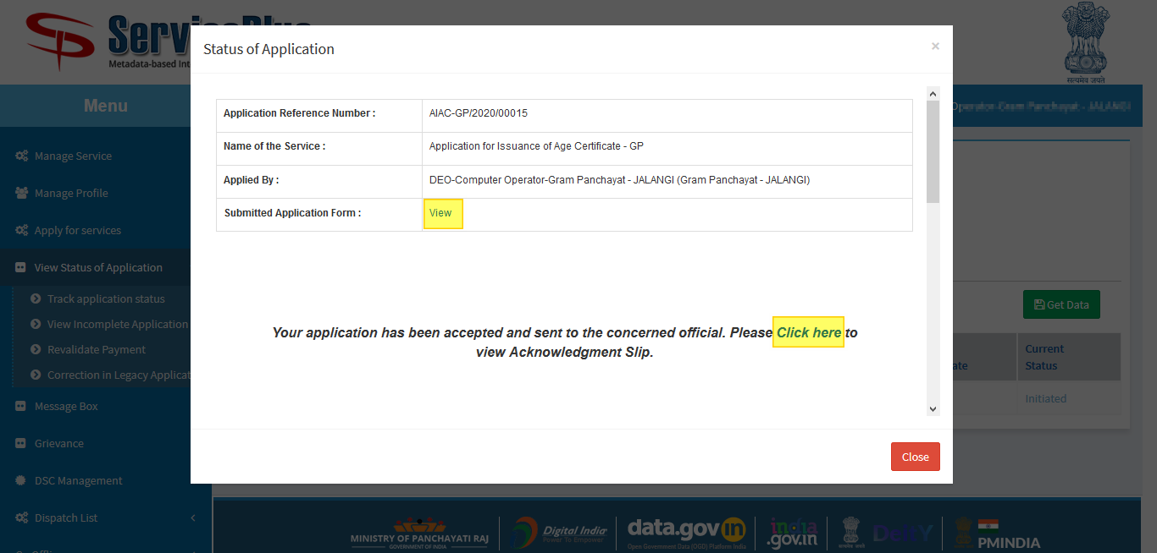

**ISSUANCE OF AGE CERTIFICATE: (By Chairman Side)**

**Step -1:**

At first login to Service plus web portal**: (**<https://tathyasathi.bangla.gov.in/>).

Login as “**CHAIRMAN**” in Service plus web portal.

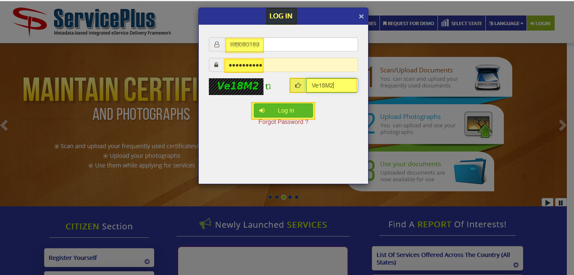

**Step -2:**

Now Go to **“Message Box”** and select **“Inbox”**.

In Inbox select the service **“Application for Issuance of Age Certificate – GP”** and select the task **“Issuance Authority”** and select **“Get Data”.**

Select **“Pull”/ “Take Action”** to take action.

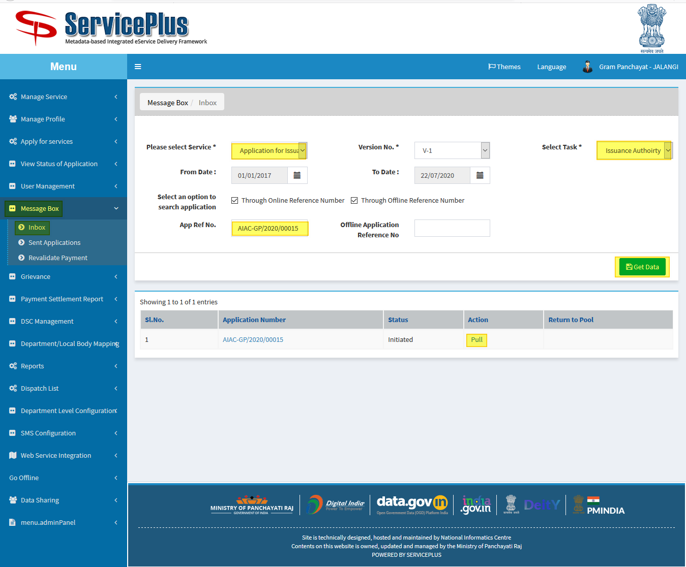

**Step 3:**

Select **“View Processing History”** to see the history of the application.

Action of the form can be taken by **CHAIRMAN** by taking action in two steps to **forward** or **Reject** and Give remarks and submit.

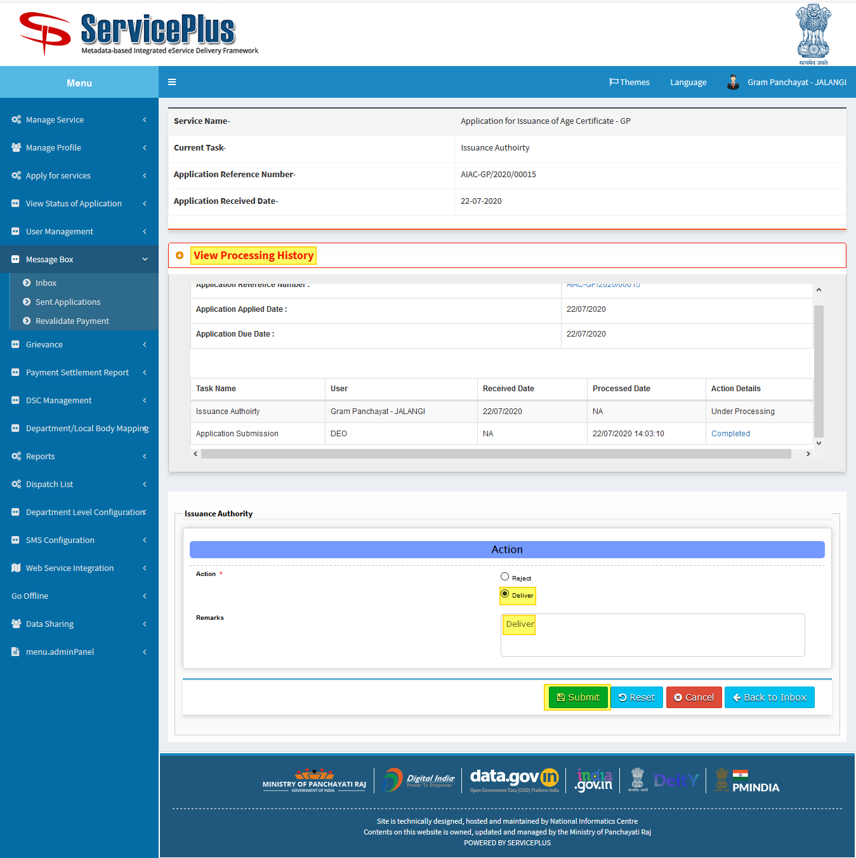

**Step 4:**

Now download the document by clicking the file icon.

And submit it.

An example certificate is attached.

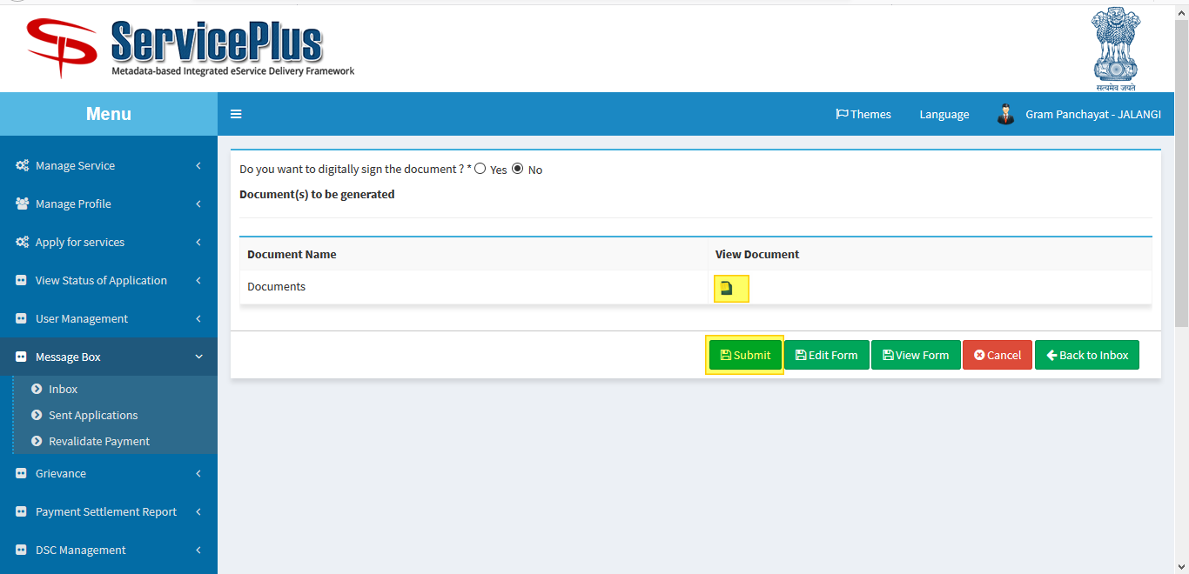

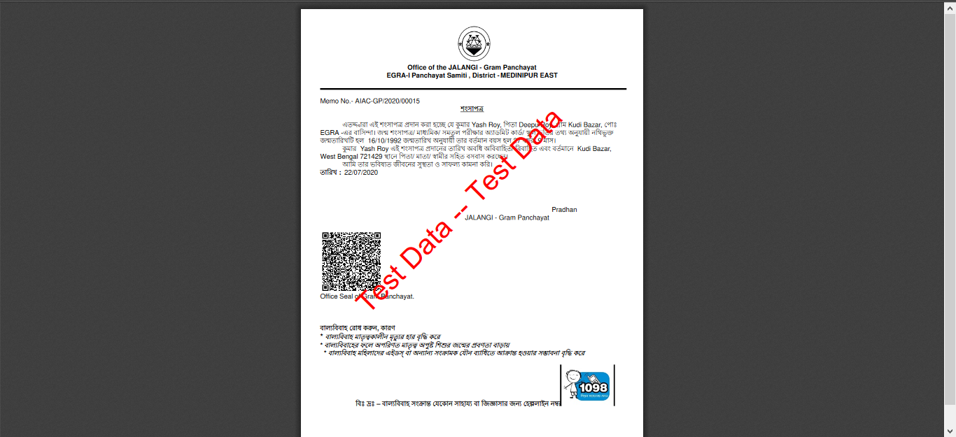

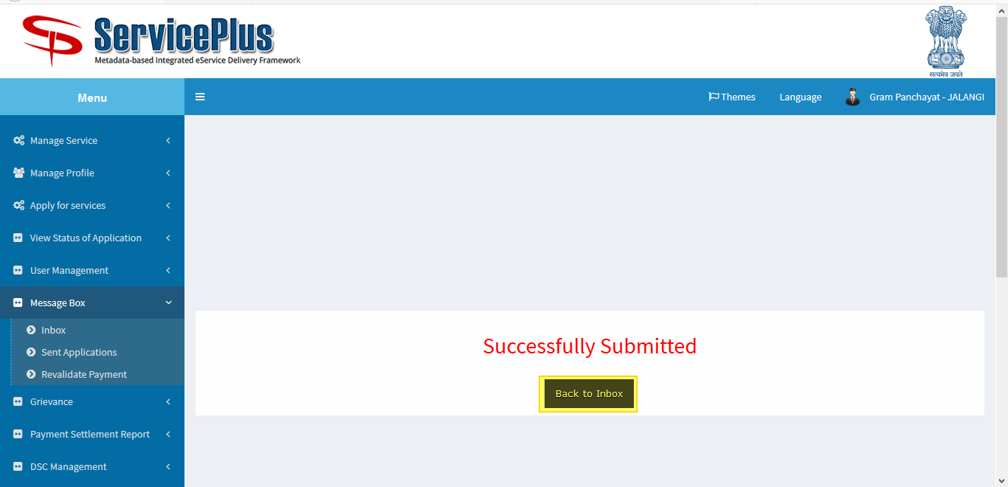

**Scanned QR CODE**

